WORK IN PROCESS PALLET TAGS

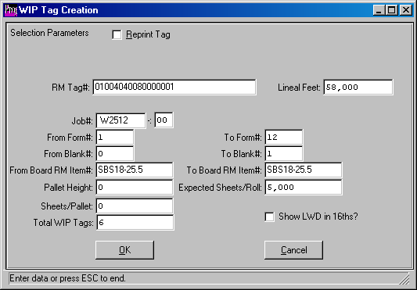

Work in Process pallet tags is a table that tracks WIP location of FG Products.
The WIP tag number will be combination of Job number, Form number, Blank number and a five digit sequential number. The table will also include following new fields: Job#, Form#, Blank#, Machine Routing Array of Machine Codes, Quantity, Produced, Pallet Qty, Shift, WIP Warehouse, WIP RM Bin, User ID Added, UserID Time Added, User ID Date Added, User ID Changed, UserID Time Changed and User ID Date Changed. The WIP table will also display the Warehouse, WIP Location, RM Item, FG Item and Customer Code. New menu will create work in process (WIP) load tags. The WIP load tag form may be formatted as desired by the customer via the Label Matrix Software to print any of the fields listed in the WIP table. The WIP tags may be printed in the office based on an expected quantity per pallet or printed after each machine operation with the exact quantity per pallet. The jobs form MRP quantity of sheets will be similar to the Order Quantity of a finished goods load tag. The print selection screen will require job number and form numbers. The worksheet will display the Job number, Customer, Finished Goods Item, Form, Raw Material Item, Sheet Width, Length and Board Forms MRP Sheets. Once the user will enter the Quantity per Pallet, the system will calculated the number of tags to print. All the fields will be downloaded to the new WIP LOADTAG file including WipTag Number, RM warehouse, RM Bin, customer code, finished goods item, raw material board item, number out, number up, job#, form#, pallet quantity and create a text file to print the WIP LOAD TAG. The fields are needed to create WIP reports by either sheets or blanks by FG Item, location and machine completed. Hence, WIP quantity by machine code and location.

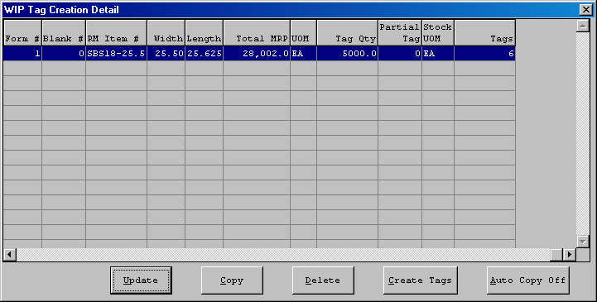

As each machine processes the board material, each pallet of sheets processed will have a unique WIP tag that represents the quantity of sheets on that pallet. Creating WIP tags will be a guess as to how many sheets will be loaded via the board material. The original WIP tag will should not have a quantity as the estimated quantity is just to produce a sufficient quantity of tags. Alternatively, each tag could be created after each machine process. No matter when the WIP tags are originally printed, a separate production data entry process is required to enter the current quantity of sheets after each machine operation. Likewise, the exact machine locations or warehouse and bin location may be entered for each WIP Tag. This is the required data that provides a work in process report of inventory quantity and value.

Sheeting Roll Tags may produce a larger number of WIP pallet tags that will be validated via WIP data collection. For example, we could add WIP Tags for Raw Material Tag# 01004040080000001, which represents the original board purchase order number, line number and sequential pallet number. Once entered or scanned via bar code, the WIP TAG worksheet will display a screen to Enter how many Sheets per Pallet Tag.
This raw material tag 01004040080000001has 58000LF on Hand.
The tag is for Jobs W2512 which has a sheet length of 25.625 inches.
Therefore, the expected number of sheets are 58,000 x 12" / 25.625 = 27,162 Expected Sheets. The user can enter a pallet stacking height = 60"
Sheets per Pallet = Stacking Height minus 5" Pallet divided by Caliper for Raw Material.
Or 60 - 5 / .018 = 3055 sheets per pallet.
WIP Tags = Expected Sheets / Sheets per Pallet
WIP Tags = 27,162 / 3055
WIP Tags = 8.89 rounded to 9.

To verify that a raw material tag has been consumed, the RM tag will update the WIP tag. Hence, scanning the same RM tag number will display warning that RM tag was already used to create a WIP tag.

